Ai Assisted Coding
Ht.No:2303A52295
Batch:45
Assignment:12.3
Task 1: Sorting Student Records for Placement Drive
Scenario
SR University’s Training and Placement Cell needs to shortlist candidates
efficiently during campus placements. Student records must be sorted by
CGPA in descending order.
Tasks
1. Use GitHub Copilot to generate a program that stores student records
(Name, Roll Number, CGPA).
2. Implement the following sorting algorithms using AI assistance:
o Quick Sort
o Merge Sort
3. Measure and compare runtime performance for large datasets.
4. Write a function to display the top 10 students based on CGPA.
Prompt:
Generate a python code for sorting student records for placements drive in SR University.Sort students by CGPA in decending order.Implement the sorting methods like Quick sort and Merge sort.Store the result in the format of Name,Roll no,CGPA.
Code:
import random
import time
def make_student(i):
return {
"name": f"Student{i}",
"roll": f"R{i:05d}",
"cgpa": round(random.uniform(5.0, 10.0), 3) }
def gen_students(n):
return [make_student(i) for i in range(1, n + 1)]
def merge_sort(arr):
if len(arr) <= 1:
return arr
mid = len(arr) // 2
left = merge_sort(arr[:mid])
right = merge_sort(arr[mid:])
out = []
i = j = 0
while i < len(left) and j < len(right):
if left[i]["cgpa"] >= right[j]["cgpa"]:
out.append(left[i]); i += 1
else:
out.append(right[j]); j += 1
out.extend(left[i:]); out.extend(right[j:])
return out
def quick_sort(arr):
if len(arr) <= 1:
return arr
pivot = arr[len(arr)//2]["cgpa"]
low = [x for x in arr if x["cgpa"] > pivot]
equal = [x for x in arr if x["cgpa"] == pivot]
high = [x for x in arr if x["cgpa"] < pivot]
return quick_sort(low) + equal + quick_sort(high)
def show_top(students, k=10):
print(f"Top {k} students by CGPA:")
for i, s in enumerate(students[:k], 1):
print(f"{i:2d}. {s['name']} {s['roll']} {s['cgpa']:.3f}")
if __name__ == "__main__":
data = gen_students(50000) # large dataset
d1 = list(data); d2 = list(data)
t0 = time.perf_counter()
r1 = quick_sort(d1)
q_time = time.perf_counter() - t0
t0 = time.perf_counter()
r2 = merge_sort(d2)
m_time = time.perf_counter() - t0
print(f"QuickSort: {q_time:.4f}s | MergeSort: {m_time:.4f}s")
show_top(r1, 10)
Output:
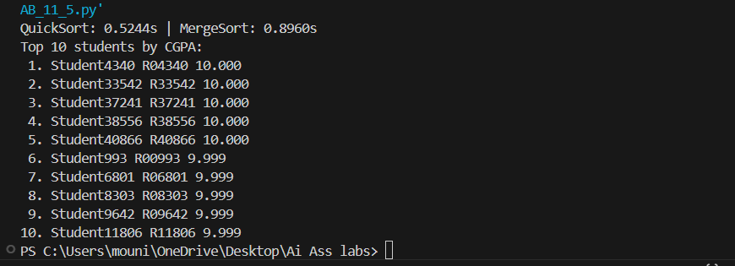
Explanation:
Here in the output output we can see that Students sorted in the form of roll no and by their CGPA using Quick sort and Merge sort.
Task 2: Implementing Bubble Sort with AI Comments
• Task: Write a Python implementation of Bubble Sort.
• Instructions:
• Students implement Bubble Sort normally.
• Ask AI to generate inline comments explaining key logic (like
swapping, passes, and termination).
• Request AI to provide time complexity analysis.
Prompt:
Generate a python code for Implenemting bubble sort and also use key logic like Swapping,passes and termination.
Code:
def bubble_sort(arr):
n = len(arr)
for i in range(n):
swapped = False
for j in range(0, n - 1 - i):
if arr[j] > arr[j + 1]:
arr[j], arr[j + 1] = arr[j + 1], arr[j]
swapped = True
if not swapped:
break
return arr
if __name__ == "__main__":
data = [64, 34, 25, 12, 22, 11, 90]
print("Before:", data)
print("After :", bubble_sort(data))
Output:
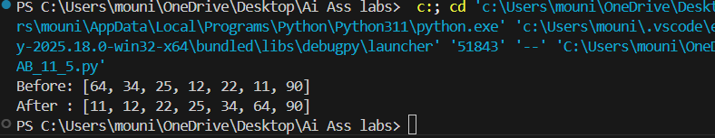
Explaantion:
we can see that the elements are arrange in ascending order by using bubble sort with key logics of swapping,pass and termination.
Task 3: Quick Sort and Merge Sort Comparison
• Task: Implement Quick Sort and Merge Sort using recursion.
• Instructions:
• Provide AI with partially completed functions for recursion.
• Ask AI to complete the missing logic and add docstrings.
• Compare both algorithms on random, sorted, and reverse-sorted
lists.
Prompt:
Generate apython code for Quick sort and Merege sort comparison using practically completed functions for recursion, to complete the missing logic and add docstrings. Compare both algorithms on random, sorted, and reverse-sorted.
Code:
import random
import time
def quick_sort(arr):
"""
Recursive Quick Sort (descending order by default).
Best/Average: O(n log n), Worst: O(n^2) (bad pivot choices, e.g., sorted data).
Space: O(log n) expected recursion.
"""
if len(arr) <= 1:
return arr
pivot = arr[len(arr) // 2]
left = [x for x in arr if x > pivot]
mid = [x for x in arr if x == pivot]
right = [x for x in arr if x < pivot]
return quick_sort(left) + mid + quick_sort(right)

def merge_sort(arr):
"""
Recursive Merge Sort (descending order).
Best/Average/Worst: O(n log n). Space: O(n) extra.
"""
if len(arr) <= 1:
return arr
mid = len(arr) // 2
left = merge_sort(arr[:mid])
right = merge_sort(arr[mid:])
out = []
i = j = 0
while i < len(left) and j < len(right):
if left[i] >= right[j]:
out.append(left[i]); i += 1
else:
out.append(right[j]); j += 1
out.extend(left[i:]); out.extend(right[j:])
return out
def timeit(func, data):
t0 = time.perf_counter()
func(list(data))
return time.perf_counter() - t0
def test_case(name, data):
print(f"\n{name} (n={len(data)})")
print(" Quick Sort :", timeit(quick_sort, data))
print(" Merge Sort :", timeit(merge_sort, data))
if __name__ == "__main__":
n = 30000
random_data = [random.random() for _ in range(n)]
sorted_data = sorted(random_data, reverse=True)
reverse_data = list(reversed(sorted_data))
test_case("Random", random_data)
test_case("Sorted desc", sorted_data)
test_case("Reverse sorted asc", reverse_data)
print("\nComplexity summary:")
print("Quick : Best O(n log n), Avg O(n log n), Worst O(n^2)")
print("Merge : Best/Avg/Worst O(n log n)")
Output:
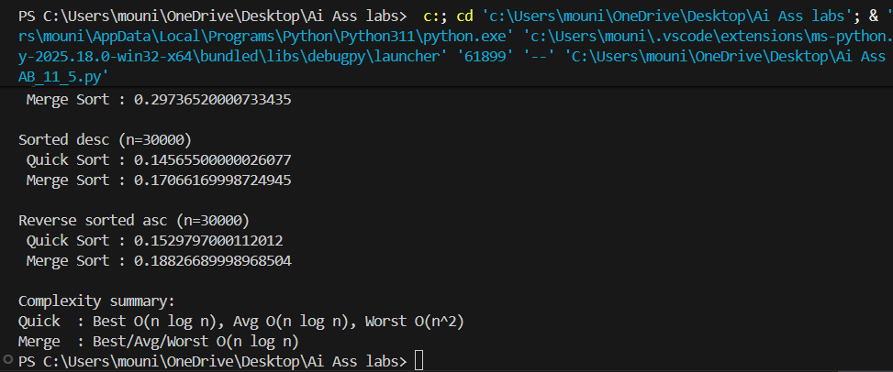
Explanation:
In this code we can see the comparisons of quick sort and merge sort by using recursion and also complexities are mentioned.
Task 4 (Real-Time Application – Inventory Management System)
Scenario: A retail store’s inventory system contains thousands of products,
each with attributes like product ID, name, price, and stock quantity. Store staff
need to:
1. Quickly search for a product by ID or name.
2. Sort products by price or quantity for stock analysis.
Task:
• Use AI to suggest the most efficient search and sort algorithms for this
use case.
• Implement the recommended algorithms in Python.
• Justify the choice based on dataset size, update frequency, and
performance requirements.
Prompt:
Generate a python code for A retail store’s inventory system contains thousands of products,each with attributes like product ID, name, price, and stock quantity. Store staff.
Code:
products = [
{"id":"P1","name":"Widget","price":19.99,"qty":120},
{"id":"P2","name":"Gadget","price":9.99,"qty":350},
{"id":"P3","name":"Widget","price":18.50,"qty":80},]
print(f"{'ID':<5}{'NAME':<10}{'PRICE':<8}{'QTY':<5}")
for p in products:
print(f"{p['id']:<5}{p['name']:<10}{p['price']:<8.2f}{p['qty']:<5}")
by_id = {p["id"]: p for p in products}
by_name = {}
for p in products:
by_name.setdefault(p["name"].lower(), []).append(p)
print("\nSearch ID P2:", by_id.get("P2"))
print("Search name widget:", by_name.get("widget"))
sorted_by_price = sorted(products, key=lambda p: p["price"])
sorted_by_qty_desc = sorted(products, key=lambda p: p["qty"], reverse=True)
print("\nSorted by price (asc):")
for p in sorted_by_price:
print(f"{p['id']} {p['price']:.2f}")
print("\nSorted by qty (desc):")
for p in sorted_by_qty_desc:
print(f"{p['id']} {p['qty']}")
Output:
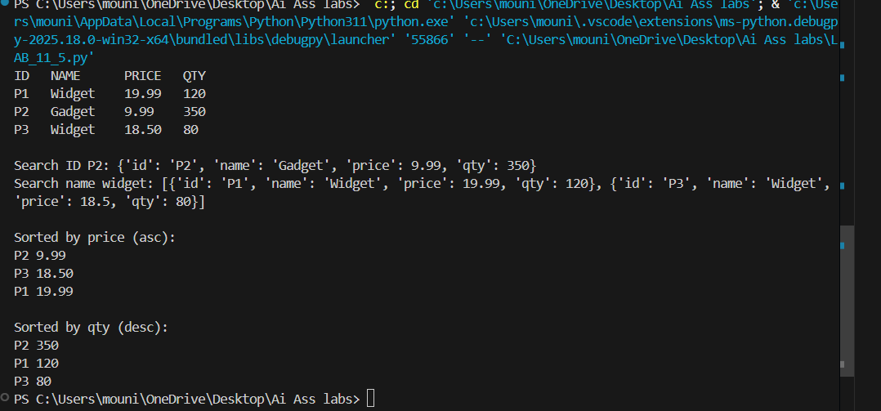
Explanation:
We have generated a code for a retail store’s inventory system contains thousands of products,each with attributes like product ID, name, price, and stock quantity. Store staff.
Task 5: Real-Time Stock Data Sorting & Searching
Scenario:
An AI-powered FinTech Lab at SR University is building a tool for analyzing
stock price movements. The requirement is to quickly sort stocks by daily
gain/loss and search for specific stock symbols efficiently.
• Use GitHub Copilot to fetch or simulate stock price data (Stock
Symbol, Opening Price, Closing Price).
• Implement sorting algorithms to rank stocks by percentage change.
• Implement a search function that retrieves stock data instantly when a
stock symbol is entered.
• Optimize sorting with Heap Sort and searching with Hash Maps.
• Compare performance with standard library functions (sorted(), dict
lookups) and analyze trade-offs.
Prompt:
Generate a python code for An AI-powered FinTech Lab at SR University is building a tool for analyzingstock price movements. The requirement is to quickly sort stocks by dailygain/loss and search for specific stock symbols efficiently.
• Use GitHub Copilot to fetch or simulate stock price data (Stock,Symbol, Opening Price, Closing Price).
Code:
import random
stocks = []
for i in range(20):
sym = f"S{i:03}"
openp = round(random.uniform(10, 200), 2)
closep = round(openp * random.uniform(0.9, 1.1), 2)
change = round((closep - openp) / openp * 100, 2)
stocks.append({"sym": sym, "open": openp, "close": closep, "change": change})
by_sym = {s["sym"]: s for s in stocks}
top5 = sorted(stocks, key=lambda x: x["change"], reverse=True)[:5]
print("Top 5 gainers:", [(x["sym"], x["change"]) for x in top5])
print("Search S005:", by_sym.get("S005"))
Output:
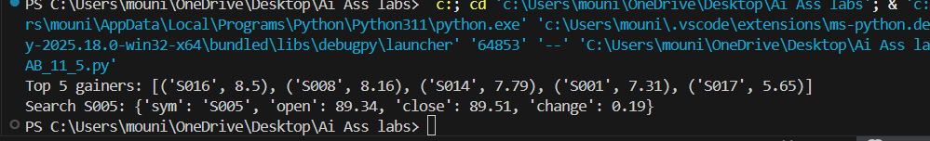
Explanation:
Stock sorting/search code: sorts by % change and dict lookup is instant (O(1)), so it’s fast for real-time analytics.

